Name: ________________________________________________ Date: __________________ Per.: ______

**Economics Honors – Career & Personal Finance Activity**

**Part I – Career Choices**

Description of Job: ________________________________________________________________________

Education/Training Required: ______________________________________________________________

Where do you plan to live: _________________________________________________________________

Entry Salary/Pay (before tax): ___________________ Monthly Take-Home Pay (before tax): _____________

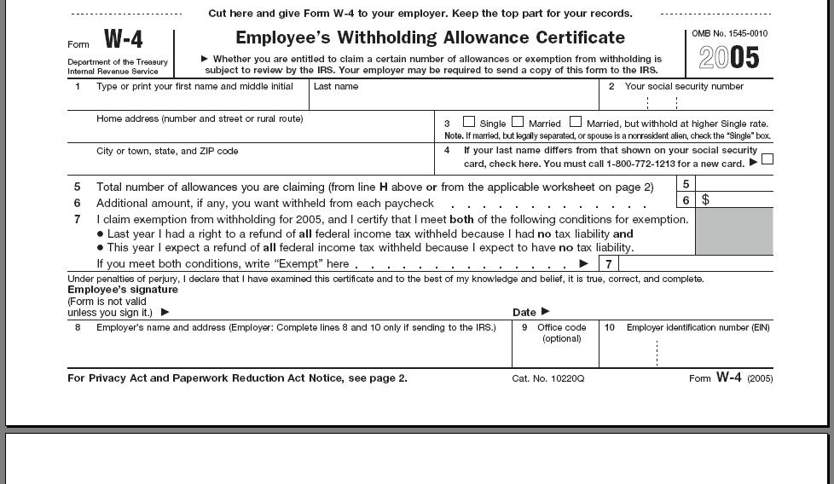**Complete this sample W-4 Form** – this is a required form for all employees to complete upon hire. This form tells the US Government how many allowances/dependents you intend to claim on your federal income taxes for this year. **DO NOT WRITE YOUR REAL SOCIAL SECURITY NUMBER.**

|  |
| --- |
| **Federal Tax Computation Chart** |
| * **FICA** tax is 6.2% of monthly earnings and **Medicare** tax is 1.4% of monthly earnings. * **Federal** **Taxes**- claiming **one**- over $30,000 annual=11%, under $29,999=9%, and under $20,000=5% for this project. * **Federal** **Taxes**-claiming **zero**-over $30,000 annual=13%, under $29,999=10%, and under $20,000=6% for this project |

**Part II – Select a Financial Institution**

Name of Banking Institution: __________________________________________________________________

Checking Account Fee? ______________ Overdraft Fee? __________________ Min. Balance? _____________

Why did you select this bank? What services do they provide?

What types of services will you use?

**ALERT - You have $25,000 in Student Loan Debt and repayment begins now. Your monthly payment is $225 per month.**

**Part III – Secure Housing** - You need to find adequate housing by renting an apartment. You may share an apartment with another person. You cannot be living rent free with family or friends.

Location of Apartment/Housing: ______________________________________________________________________

Rent: _________________________ Is there anything included with the rent? ___________________________________

**Complete this Tenant Application Form – *do not use your real Social Security Number***

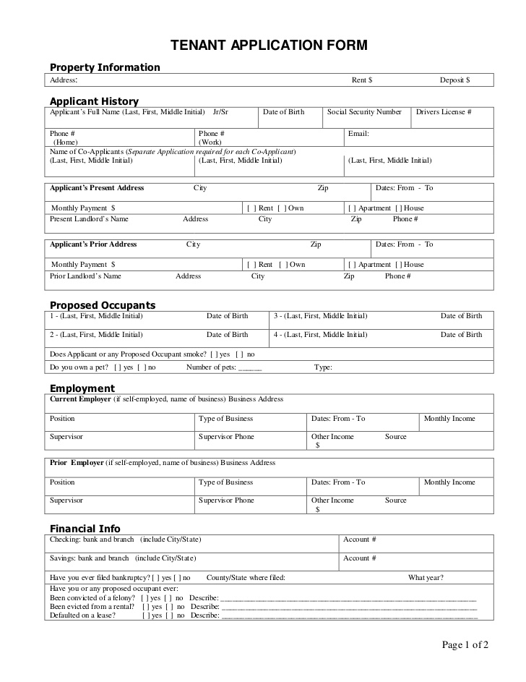

**Part IV – Transportation**

You decided to purchase a new SUV right out of college. **Your monthly payment is $305 per month.**

You need to secure insurance for your vehicle. Research the cost of insurance, gas, car washes and oil changes for your SUV.

What will your monthly payment be? ________________________________

How much will you spend in gas each month? _________________________

Car Wash? ______________________ Oil Changes (every three month)? _________________________

**Part V – Utilities**

Research the cost for all of the utilities that you will be responsible for that are not including in the housing arrangement. These may include, but are not limited to, cable, online services, electricity, trash, water, and others.

Research and decide how much you will spend for these services each month.

Cell Phone ________________

Internet __________________

TV ______________________

Electric __________________

Trash ____________________

Water ____________________

Other (list them) ____________________________________________________________________________

**Part VI – Food & Clothing** Research says that most single college grads spend about $160 per month on food and clothing. How much of your budget will you allocate for: Food _____________ Clothes ______________

**Part VII – Entertainment**

You go out with your friends every Friday night and spend $50 each time. **Your entertainment expenses are $200 per month.**

**Part VII – Savings**

Financial planner suggest saving 20% of every paycheck. How much do you intend to save each month?

Savings ________________________

**Part VII – Miscellaneous**

Will you donate to any charitable or religious organizations? Are there expenditures that you have now that you plan to have in the future? Will you purchase a gym membership? Get your hair/nails done? Go on trips?

Miscellaneous Budget ____________________

**Monthly Budget Report Sheet**

1. **Computing Monthly Net Income**

|  |  |
| --- | --- |
| Gross Income......................................................................... | $_____________ |
| FICA Amount................................................................... | $_____________ |
| Medicare Tax.................................................................... | $_____________ |
| Federal Tax....................................................................... | $_____________ |
| Net Income............................................................................ | $_____________ |

**2. Monthly Expenditures**

|  |  |
| --- | --- |
| Rent…………………………………………………....... | $______________ |
| Vehicle Cost Per Month……………………………....... | $______________ |
| Monthly Vehicle Insurance Payment…………………... | $______________ |
| Monthly Renters Insurance Cost...................................... | $______________  $______________ |
| Monthly Payment on Student Loan(s) ………………… |
| Monthly Phone/Cell Phone Cost...................................... | $______________ |
| Utilities Monthly Cost (total from below)........................ | $______________ |
| Cable.................................................$____________ |  |
| Electric/Gas......................................$____________ |  |
| Water................................................$____________ |  |
| Trash.................................................$____________  Other……………………………….$____________ |  |
| Monthly food/clothing costs.............................................  (minimum $160 for food + clothing) | $______________ |
| Entertainment Costs......................................................... | $______________ |
| Monthly Gasoline/Maintenance Costs............................. | $______________ |
| Savings Deposits.............................................................. | $______________ |
| Contributions/Monthly Donations................................... | $______________ |
| Total Monthly Expenditures............................................ | $______________ |
| Monthly Net (bring home) Income................................... | $______________ |
| Monthly Surplus or Deficit......................................+ or - | $______________ |